Nom de l’équipe : _____________________________________

Nom des participants : _________________________________

Carnet de compétition

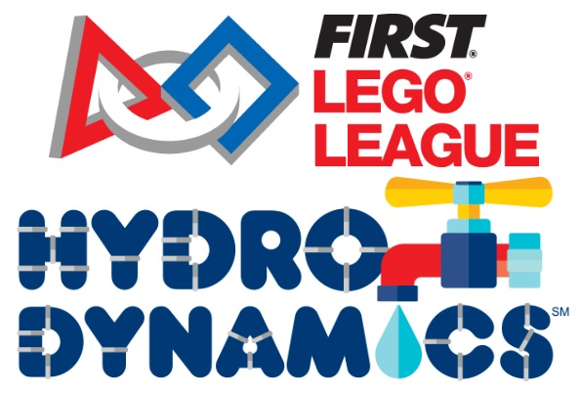

Calendrier de la compétition

Légende :
Compétition : Séances :
Qualification :
Fin du concours :

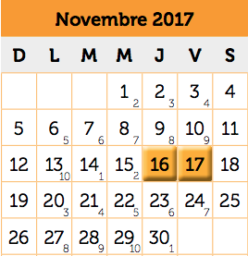
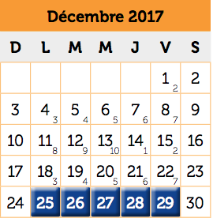

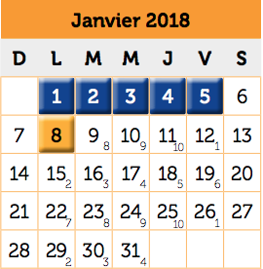
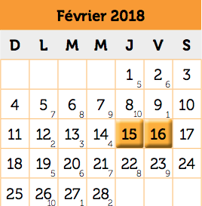

Modalités de la compétition

Tu as 1 minute 45 secondes au maximum pour compléter les trois défis.
En cas d’égalité au niveau des points, l’équipe qui sera la plus rapide aura priorité.

Mission 1 : -Mission 1 : Tu dois faire lever le niveau d’eau de la fontaine en déposant correctement le baril d’eau dans la cuve grise. [25 points]

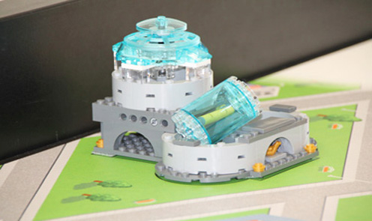
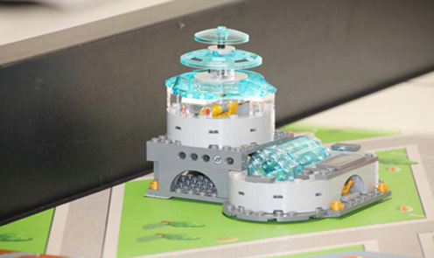
25 points

Mission 2 : Bouge la pompe supplémentaire de manière à ce qu’elle se colle complètement à celle sur le côté du mur. [20 points]
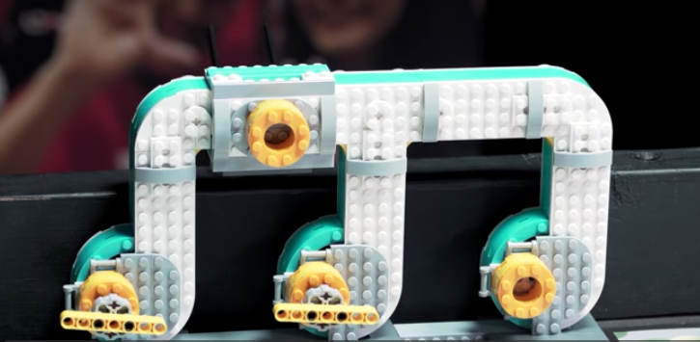

20 points

Mission 3 : Tu dois bouger le filtre en direction nord jusqu’à ce que le loquet de verrouillage soit enfoncé au maximum.

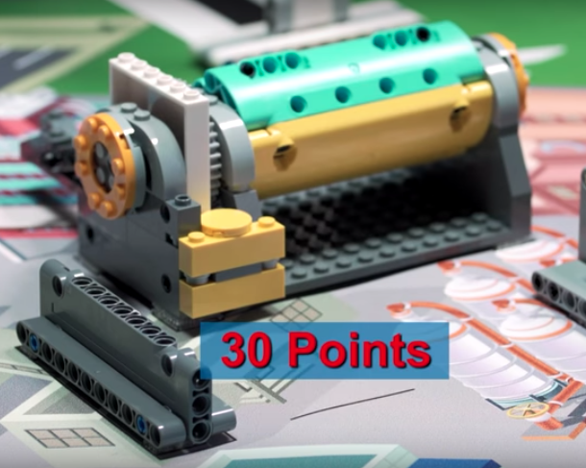
15 points

Planification globale

A) Combien d’objectifs : pourquoi
B) Lesquels en premier : pourquoi
C) Quand et comment y arriver ?

Réponse :____________________________________________________________________________________________________________________________________________________________________________________________________________________________________________________________________________________________________________________________________________________________________________________________________________________________________________________________________________________________________________________________________________________________________________________________________________________________________________________

Ressources à ta disposition si tu as des questions

1)https://www.youtube.com/channel/UCvuw_UluXNRPKhqK5GU8SrQ

2) https://www.youtube.com/watch?v=sptdZEUFf9o&t=17s

3)https://www.youtube.com/watch?v=PrU-dTeD23M&index=8&list=PL69EqNt0RGwp-GFnaHsAvbqPlvZYDeK5o
4) https://www.youtube.com/user/legorobotic/videos
Date : __________
Séance 1

Objectif pour la séance : ___________________________________________________________________________________
______________________________________________________________________________________________________________________________________________________________________________________________________________________________
Laisse des traces de ce qui s’est passé, (les essaies, les erreurs) :______________________________________
__________________________________________________________________________________________________________________________________________________________________________________________________________________________________________________________________________________________________________________________________________________________________________________________________________________________________________________________________________________________________________________________________________________________________________________________________________________________________________________________________________________________
Je note mes progrès : ______________________________________________________________________________________
_____________________________________________________________________________________________________________________________________________________________________________________________________________________________________________________________________________________________________________________________________________
Dessins:

Défi 1 | Défi 2 | Défi 3
Objectif atteint : Oui

Non

v
Date : _____________
Séance 2

Objectif pour la séance : ___________________________________________________________________________________
______________________________________________________________________________________________________________________________________________________________________________________________________________________________
Laisse des traces de ce qui s’est passé, (les essaies, les erreurs) :______________________________________
__________________________________________________________________________________________________________________________________________________________________________________________________________________________________________________________________________________________________________________________________________________________________________________________________________________________________________________________________________________________________________________________________________________________________________________________________________________________________________________________________________________________
Je note mes progrès : ______________________________________________________________________________________
_____________________________________________________________________________________________________________________________________________________________________________________________________________________________________________________________________________________________________________________________________________
Dessins:

Défi 1 | Défi 2 | Défi 3
Objectif atteint : Oui

Non

v
Date : __________
Séance 3

Objectif pour la séance : ___________________________________________________________________________________
______________________________________________________________________________________________________________________________________________________________________________________________________________________________
Laisse des traces de ce qui s’est passé, (les essaies, les erreurs) :______________________________________
__________________________________________________________________________________________________________________________________________________________________________________________________________________________________________________________________________________________________________________________________________________________________________________________________________________________________________________________________________________________________________________________________________________________________________________________________________________________________________________________________________________________
Je note mes progrès : ______________________________________________________________________________________
_____________________________________________________________________________________________________________________________________________________________________________________________________________________________________________________________________________________________________________________________________________
Dessins:

Défi 1 | Défi 2 | Défi 3
Objectif atteint : Oui

Non

v
Date : _____________
Séance 4

Objectif pour la séance : ___________________________________________________________________________________
______________________________________________________________________________________________________________________________________________________________________________________________________________________________
Laisse des traces de ce qui s’est passé, (les essaies, les erreurs) :______________________________________
__________________________________________________________________________________________________________________________________________________________________________________________________________________________________________________________________________________________________________________________________________________________________________________________________________________________________________________________________________________________________________________________________________________________________________________________________________________________________________________________________________________________
Je note mes progrès : ______________________________________________________________________________________
_____________________________________________________________________________________________________________________________________________________________________________________________________________________________________________________________________________________________________________________________________________
Dessins:

Défi 1 | Défi 2 | Défi 3
Objectif atteint : Oui

Non

v
Date : __________
Séance 5

Objectif pour la séance : ___________________________________________________________________________________
______________________________________________________________________________________________________________________________________________________________________________________________________________________________
Laisse des traces de ce qui s’est passé, (les essaies, les erreurs) :______________________________________
__________________________________________________________________________________________________________________________________________________________________________________________________________________________________________________________________________________________________________________________________________________________________________________________________________________________________________________________________________________________________________________________________________________________________________________________________________________________________________________________________________________________
Je note mes progrès : ______________________________________________________________________________________
_____________________________________________________________________________________________________________________________________________________________________________________________________________________________________________________________________________________________________________________________________________
Dessins:

Défi 1 | Défi 2 | Défi 3
Objectif atteint : Oui

Non

v
Date : _____________
Séance 6

Objectif pour la séance : ___________________________________________________________________________________
______________________________________________________________________________________________________________________________________________________________________________________________________________________________
Laisse des traces de ce qui s’est passé, (les essaies, les erreurs) :______________________________________
__________________________________________________________________________________________________________________________________________________________________________________________________________________________________________________________________________________________________________________________________________________________________________________________________________________________________________________________________________________________________________________________________________________________________________________________________________________________________________________________________________________________
Je note mes progrès : ______________________________________________________________________________________
_____________________________________________________________________________________________________________________________________________________________________________________________________________________________________________________________________________________________________________________________________________
Dessins:

Défi 1 | Défi 2 | Défi 3
Objectif atteint : Oui

Non

v

