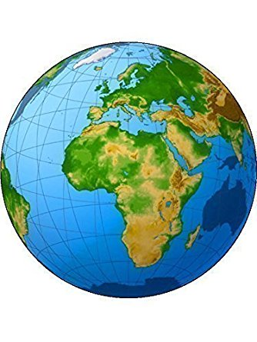Ma capsule Tour du monde

Nom des membres de l’équipe :

_______________________________________________________________

_______________________________________________________________

Pays : _________________________________

Continent : __________________________________

Nombre d’habitants : ____________________________________

Capitale : _______________________________

Religion : _______________________________

Pratiques vestimentaires : ______________________________________________________________________________________________________________________________________________________________________________________________________________________________________________________________________________

Fêtes religieuses : ______________________________________________________________________________________________________________________________________________________________________________________________________________________________________________________________________________

Autres informations sur la religion du pays :

Une activité populaire à faire :

Un monument célèbre :

Un événement important ou historique mémorable :

Notes :

________________________________________________________________________________________________________________________________________________________________________________________________________________________________________________________________________________________________________________________________________________________________________________________________________________________________________________________________________________________________________________________________________________________________________________________________________________________________________________________________________________________________________________________________________________________________________________________________________________________________________________________________________________________________________________________________________________________________________________________________________________________________________________________________________________________________________________________

__________________________________________________________________________________________