**À la découverte des trésors du monde!**



**___________________________**

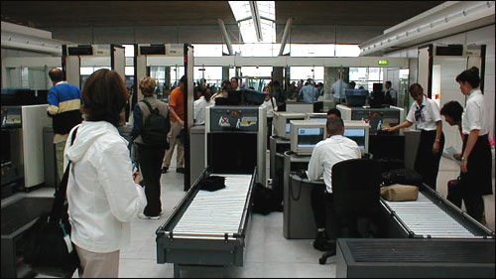

**________________________**



C

**___________________________**

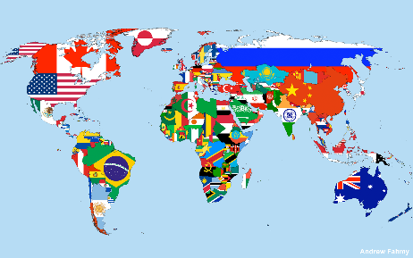

**_______________________________**

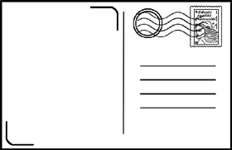

**__________________________**

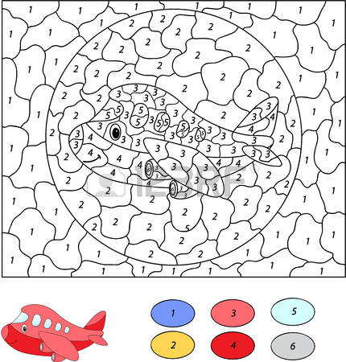

**___________________________**



**________________________**

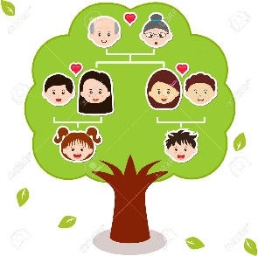

C

**___________________________**



**_______________________________**

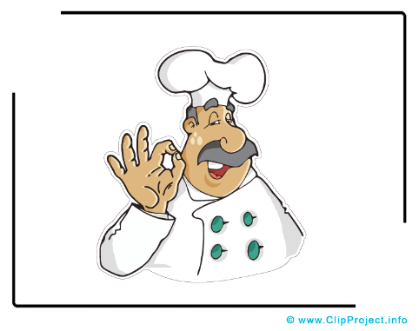

**___________________________**

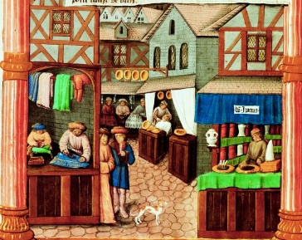

**_______________________________**

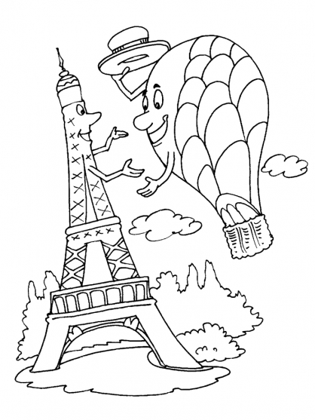

**___________________________**

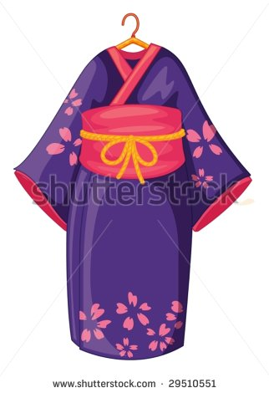

**________________________**



C

**___________________________**



**_______________________________**

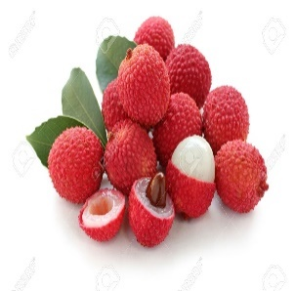

**___________________________**

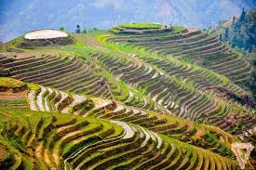

**_______________________________**

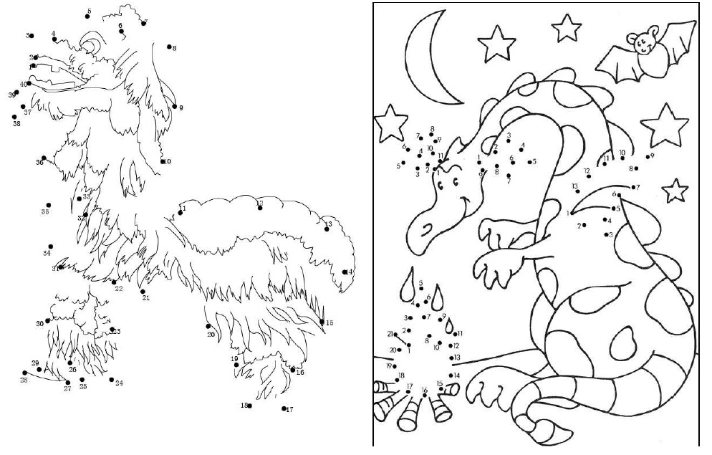

**___________________________**

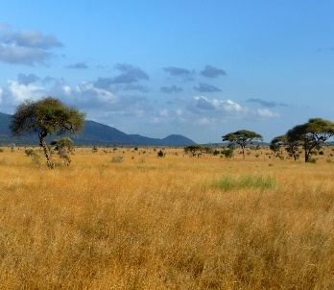

**________________________**

C

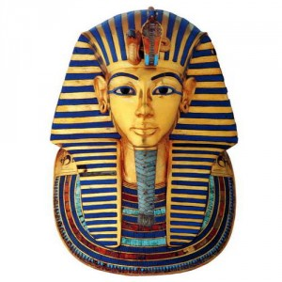

**___________________________**

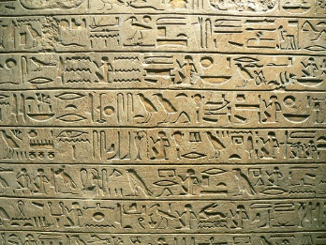

**_______________________________**



**___________________________**

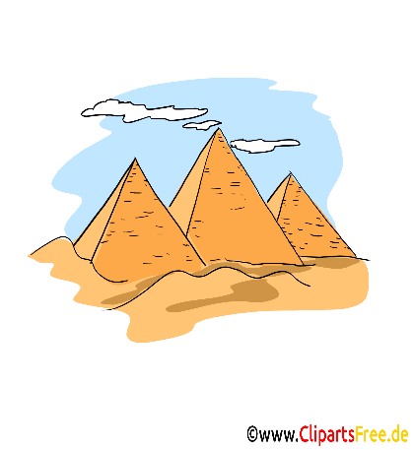

**_______________________________**

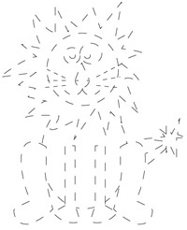

**___________________________**



**________________________**

C

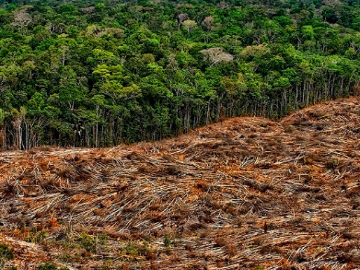

**___________________________**

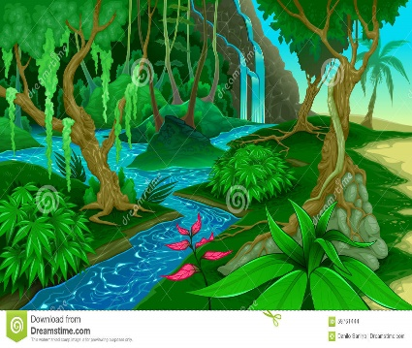

**_______________________________**

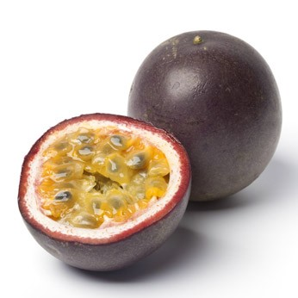

**___________________________**



**_______________________________**

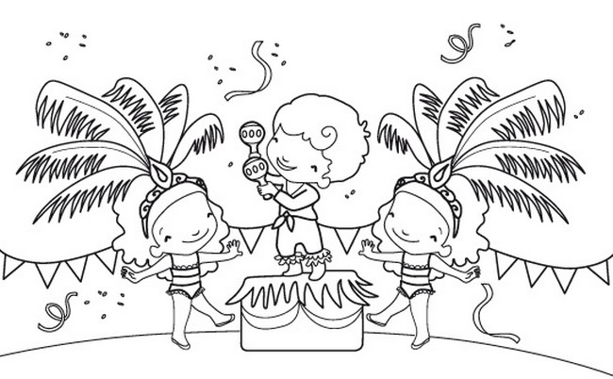

**___________________________**

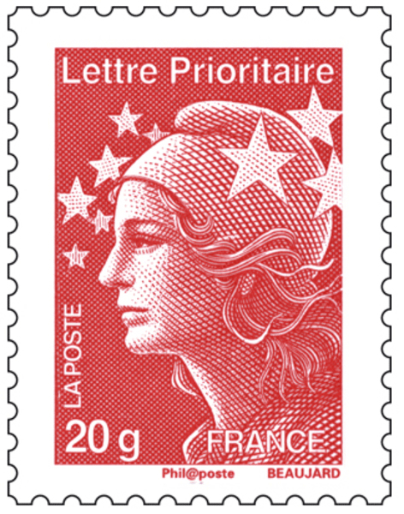

**________________________**

C

**___________________________**

**_______________________________**

**___________________________**

**_______________________________**

**___________________________**

**________________________**

C

**___________________________**

**_______________________________**

**___________________________**

**___________________________**

**________________________**

C

**___________________________**

**_______________________________**

**___________________________**

**_______________________________**