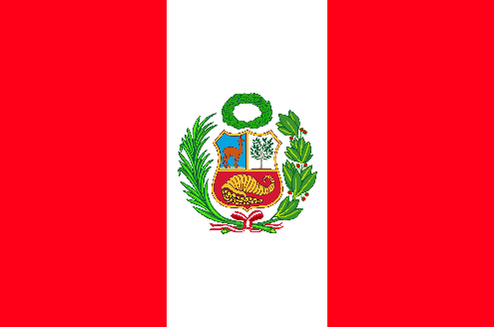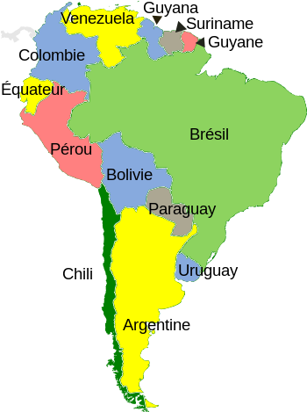**À la découverte du monde**

Pérou (Amérique du Sud)

1._______________________________________________________________________________________________________________________________2._______________________________________________________________________________________________________________________________3._______________________________________________________________________________________________________________________________4._______________________________________________________________________________________________________________________________5._______________________________________________________________________________________________________­________________________

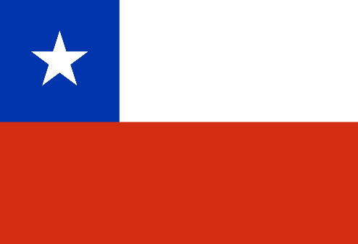**À la découverte du monde**

Chili (Amérique du Sud)

1._______________________________________________________________________________________________________________________________2._______________________________________________________________________________________________________________________________3._______________________________________________________________________________________________________________________________4._______________________________________________________________________________________________________________________________5._______________________________________________________________________________________________________­________________________

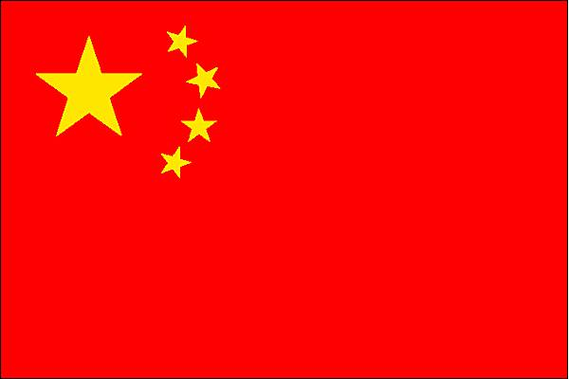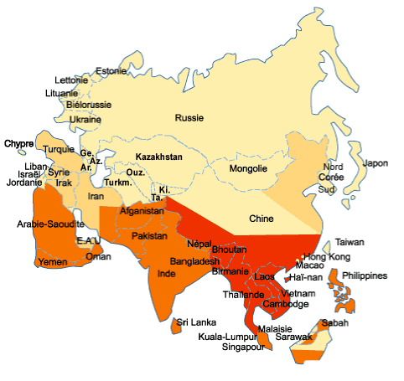**À la découverte du monde**

Chine (Asie)

1._______________________________________________________________________________________________________________________________2._______________________________________________________________________________________________________________________________3._______________________________________________________________________________________________________________________________4._______________________________________________________________________________________________________________________________5._______________________________________________________________________________________________________­________________________

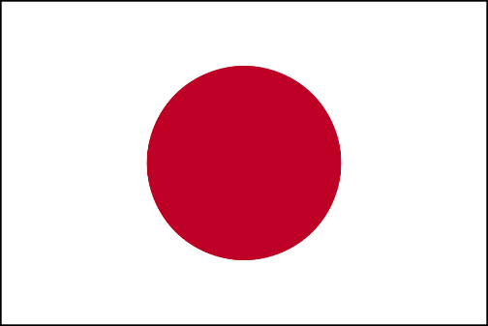**À la découverte du monde**

Japon (Asie)

1._______________________________________________________________________________________________________________________________2._______________________________________________________________________________________________________________________________3._______________________________________________________________________________________________________________________________4._______________________________________________________________________________________________________________________________5._______________________________________________________________________________________________________­________________________

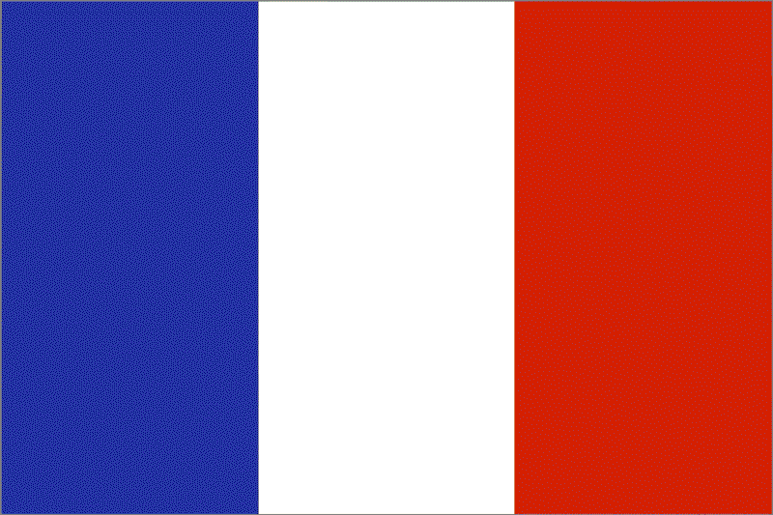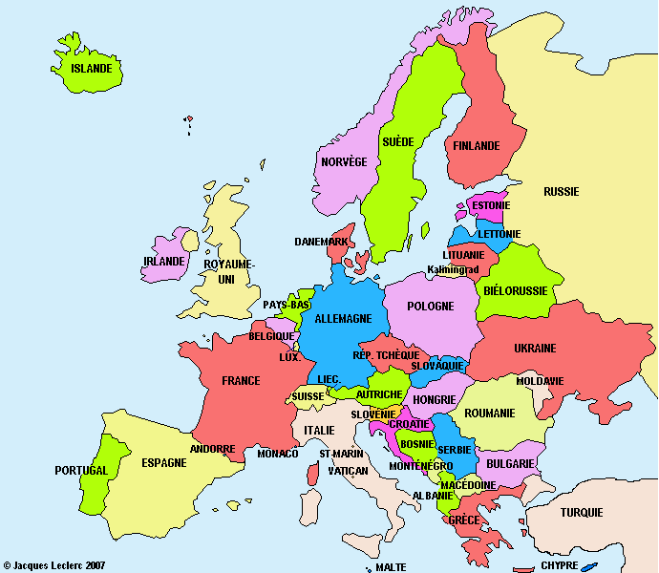**À la découverte du monde**

France (Europe)

1._______________________________________________________________________________________________________________________________2._______________________________________________________________________________________________________________________________3._______________________________________________________________________________________________________________________________4._______________________________________________________________________________________________________________________________5._______________________________________________________________________________________________________­________________________

**À la découverte du monde**

Grèce (Europe)

1._______________________________________________________________________________________________________________________________2._______________________________________________________________________________________________________________________________3._______________________________________________________________________________________________________________________________4._______________________________________________________________________________________________________________________________5._______________________________________________________________________________________________________­________________________

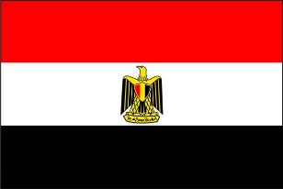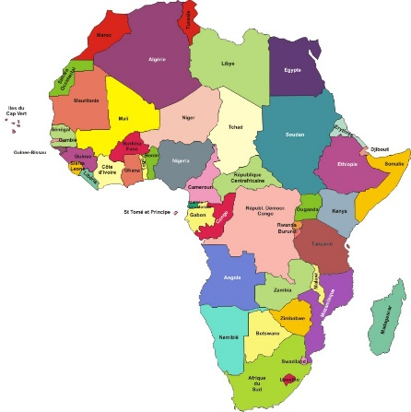**À la découverte du monde**

Égypte (Afrique)

1.____________________________________________________________________________________ ___________________________________________2.____________________________________________________________________________________ ___________________________________________3._______________________________________________________________________________________________________________________________4._______________________________________________________________________________________________________________________________5._______________________________________________________________________________________________________­________________________

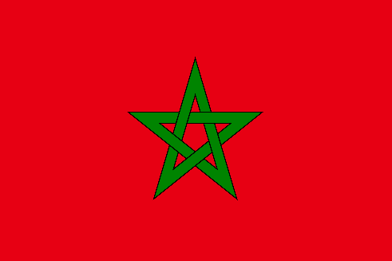**À la découverte du monde**

Maroc (Afrique)

1._______________________________________________________________________________________________________________________________2._______________________________________________________________________________________________________________________________3._______________________________________________________________________________________________________________________________4._______________________________________________________________________________________________________________________________5._______________________________________________________________________________________________________­________________________

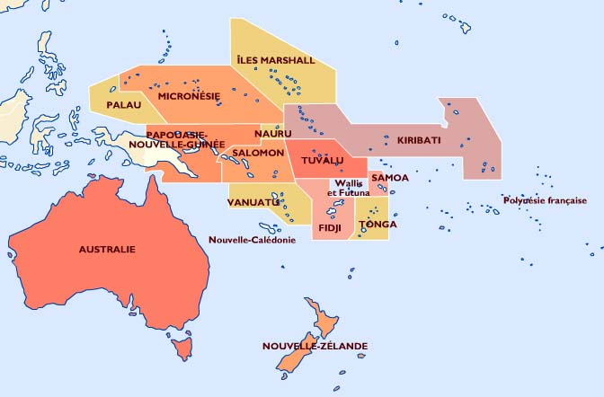**À la découverte du monde**

Nouvelle-Zélande (Océanie)

1._______________________________________________________________________________________________________________________________ 2._______________________________________________________________________________________________________________________________3._______________________________________________________________________________________________________________________________4._______________________________________________________________________________________________________________________________5._______________________________________________________________________________________________________­________________________

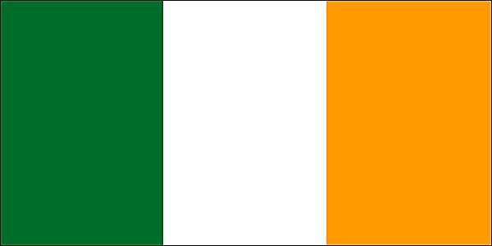**À la découverte du monde**

Irlande (Europe)

1._______________________________________________________________________________________________________________________________2._______________________________________________________________________________________________________________________________3._______________________________________________________________________________________________________________________________4._______________________________________________________________________________________________________________________________5._______________________________________________________________________________________________________­________________________

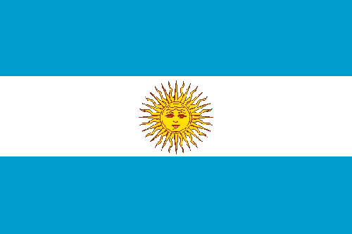**À la découverte du monde**

Argentine (Amérique du Sud)

1._________________________________________ ______________________________________________________________________________________2._______________________________________________________________________________________________________________________________3._______________________________________________________________________________________________________________________________4._______________________________________________________________________________________________________________________________5._______________________________________________________________________________________________________­________________________

**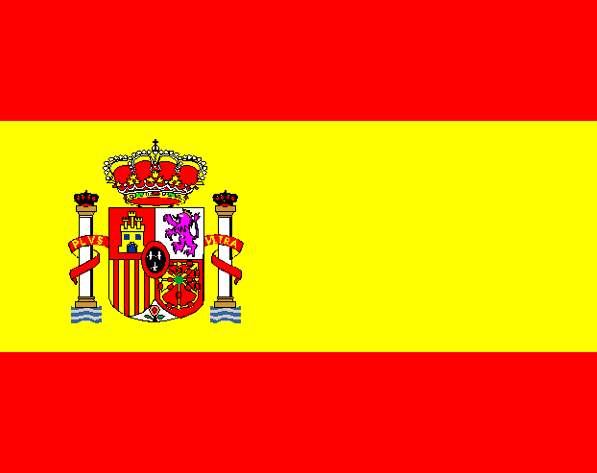****À la découverte du monde**

Espagne (Europe)

1.___________________________________________ ______________________________________________________________________________________2._______________________________________________________________________________________________________________________________3._______________________________________________________________________________________________________________________________4._______________________________________________________________________________________________________________________________5._______________________________________________________________________________________________________­________________________