Nom : ______________________

La grande fabrique de mots

Selon toi, de quoi parlera l’histoire ?

_________________________________________________________________________________________________________________________________________________________________________________________________________________________________________________________________________________________________________________________________________________________

Quel peut être ce mot que Philéas a trouvé ? Propose deux réponses et explique en quelques mots pourquoi tu les as choisis.

**Proposition 2**

________________________________________________________________________________________________________________________________________________________________________________________________________________________________________________

**Proposition 1**

________________________________________________________________________________________________________________________________________________________________________________________________________________________________________________

**Proposition 1**

________________________________________________________________________________________________________________________________________________________________________________________________________________________________________________

Questions de comprehension

1. Comment s’appelle le pays imaginaire dans lequel se déroule l’histoire ?

________________________________________________________________

1. Qu’est-ce qui rend ce pays unique ?

________________________________________________________________

1. Comment s’appelle le garçon de cette histoire ?

________________________________________________________________

1. Comment s’appelle la petite fille de cette histoire ?

________________________________________________________________

1. Quels mots le petit garçon attrape-t-il dans son filet à papillons ?

________________________________________________________________

Observe cette image : comment pouvons-nous faire la différence entre les gens riches et les gens pauvres ?

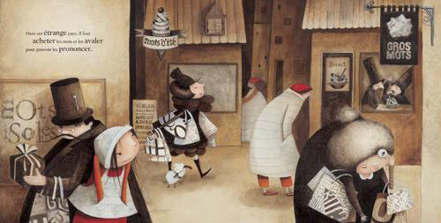

Les gens pauvres

_________________________________________________________________________________________________________________________________________________________________________________________________________________________________________________________________________________________________________________________________________________________

Les gens riches

_________________________________________________________________________________________________________________________________________________________________________________________________________________________________________________________________________________________________________________________________________________________

QUESTIONS DE REFLEXION

Comment Philéas peut-il dire je t’aime même s’il n’a pas assez d’argent ?

______________________________________________________________________

______________________________________________________________________

______________________________________________________________________

______________________________________________________________________

______________________________________________________________________

______________________________________________________________________

______________________________________________________________________

Est-ce qu’on aime plus une personne qui a de l’argent ?

______________________________________________________________________

______________________________________________________________________

______________________________________________________________________

______________________________________________________________________

______________________________________________________________________

______________________________________________________________________

______________________________________________________________________

Si tu pouvais acheter seulement trois mots (autre que *je t’aime*) pour dire que tu aimes quelqu’un, quels seraient-ils ? Pourquoi ?

______________________________________________________________________

______________________________________________________________________

______________________________________________________________________

______________________________________________________________________

______________________________________________________________________

______________________________________________________________________

______________________________________________________________________