_________________________________________________

_________________________________________________

_________________________________________________

_________________________________________________

_________________________________________________

_________________________________________________

___________

______________________________________

_________________________________________________

_________________________________________________

_________________________________________________

_________________________________________________

______________________

___________________________

_________________________________________________

_________________________________________________

_________________________________________________

_________________________________________________

_________________________________

________________

_________________________________________________

_________________________________________________

_________________________________________________

_________________________________________________

____________________________________________

_____

_________________________________________________

_________________________________________________

_________________________________________________

J

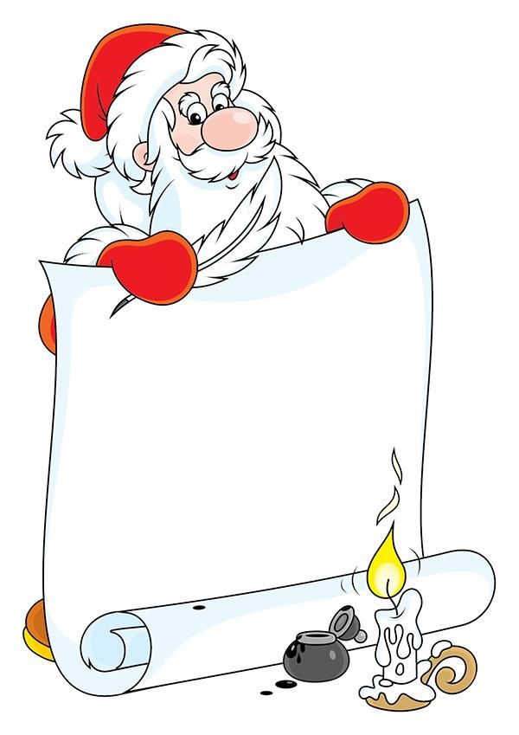

**Joyeux Noël du**

**Québec!**

