Cuisiniers: _______________________________ et ______________________________

Titre de la recette : _____________________________________________________________

Ingrédients :

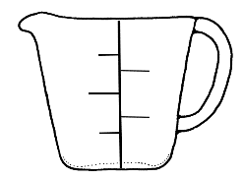________________________________________________________________________________________________________________

________________________________________________________________________________________________________________

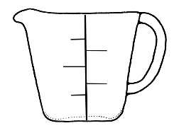________________________________________________________________________________________________________________

________________________________________________________________________________________________________________



________________________________________________________________________________________________________________

________________________________________________________________________________________________________________

Préparation :

________________________________________________________________________________________________________________

________________________________________________________________________________________________________________

________________________________________________________________________________________________________________

________________________________________________________________________________________________________________

________________________________________________________________________________________________________________

________________________________________________________________________________________________________________

________________________________________________________________________________________________________________

________________________________________________________________________________________________________________

________________________________________________________________________________________________________________

________________________________________________________________________________________________________________

________________________________________________________________________________________________________________

________________________________________________________________________________________________________________