[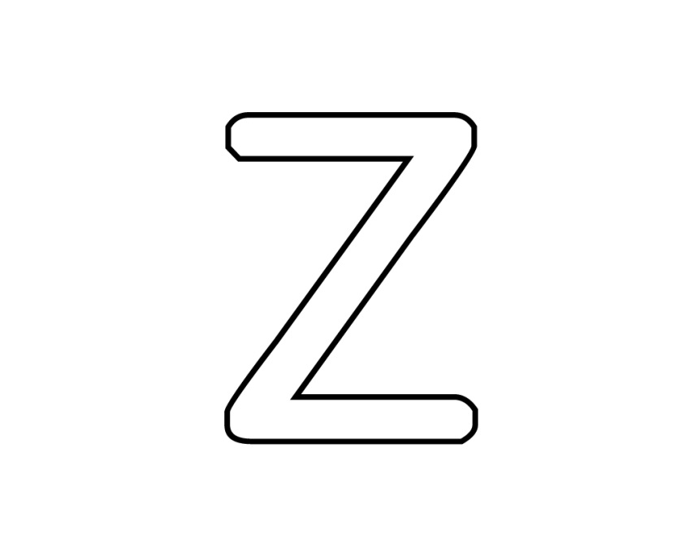](http://www.google.ca/url?sa=i&rct=j&q=&esrc=s&source=images&cd=&cad=rja&uact=8&ved=0CAcQjRxqFQoTCIT666jwg8kCFYFIPgod2fsKLQ&url=http%3A%2F%2Fwww.mes-coloriages-preferes.biz%2FColoriages%2FChiffres-et-formes%2FAlphabet%2FLettre-z&psig=AFQjCNFZuoiJE-N_m470LB1cHi9M4itFxw&ust=1447176929514410)

Lettre tracée en noir

[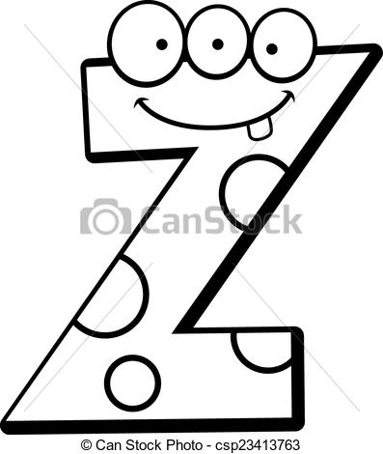](http://www.google.ca/url?sa=i&rct=j&q=&esrc=s&source=images&cd=&cad=rja&uact=8&ved=0CAcQjRxqFQoTCJ3Y0Nvwg8kCFUg4Pgodcx0BKw&url=http%3A%2F%2Fwww.canstockphoto.fr%2Flettre-z-monstre-23413763.html&bvm=bv.106923889,d.cWw&psig=AFQjCNFBBnRbUTRxcV0gBMp5LYsWRbctig&ust=1447177033128063)[](http://www.google.ca/url?sa=i&rct=j&q=&esrc=s&source=images&cd=&cad=rja&uact=8&ved=0CAcQjRxqFQoTCIT666jwg8kCFYFIPgod2fsKLQ&url=http%3A%2F%2Fwww.mes-coloriages-preferes.biz%2FColoriages%2FChiffres-et-formes%2FAlphabet%2FLettre-z&psig=AFQjCNFZuoiJE-N_m470LB1cHi9M4itFxw&ust=1447176929514410)Mot écrit Zèbre

Ressemblance

Minimum de trois caractéristiques de monstres

[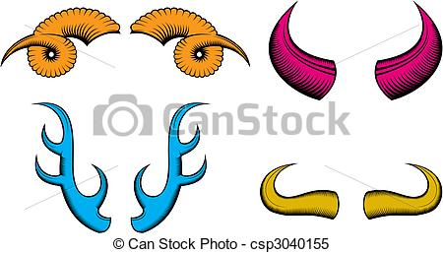](http://www.google.ca/url?sa=i&rct=j&q=&esrc=s&source=images&cd=&cad=rja&uact=8&ved=0CAcQjRxqFQoTCI2E3d_xg8kCFQEaPgodCEIBrA&url=http%3A%2F%2Fwww.canstockphoto.fr%2Fcornes-3040155.html&bvm=bv.106923889,d.cWw&psig=AFQjCNGrCOv0CkoCulQWNATVIalp_2h50g&ust=1447177301204137)[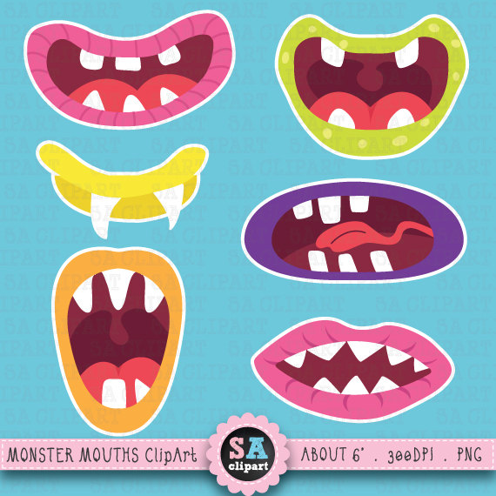](https://www.google.ca/url?sa=i&rct=j&q=&esrc=s&source=images&cd=&cad=rja&uact=8&ved=0CAcQjRxqFQoTCO33h7fxg8kCFYnJPgodeEoCdg&url=https%3A%2F%2Fwww.etsy.com%2Ffr%2Flisting%2F189034782%2Fmignon-monstre-bouche-monster-bouches&bvm=bv.106923889,d.cWw&psig=AFQjCNEnvundCqaaaUdgXLOlfwt5Mp8Fgg&ust=1447177223776690)[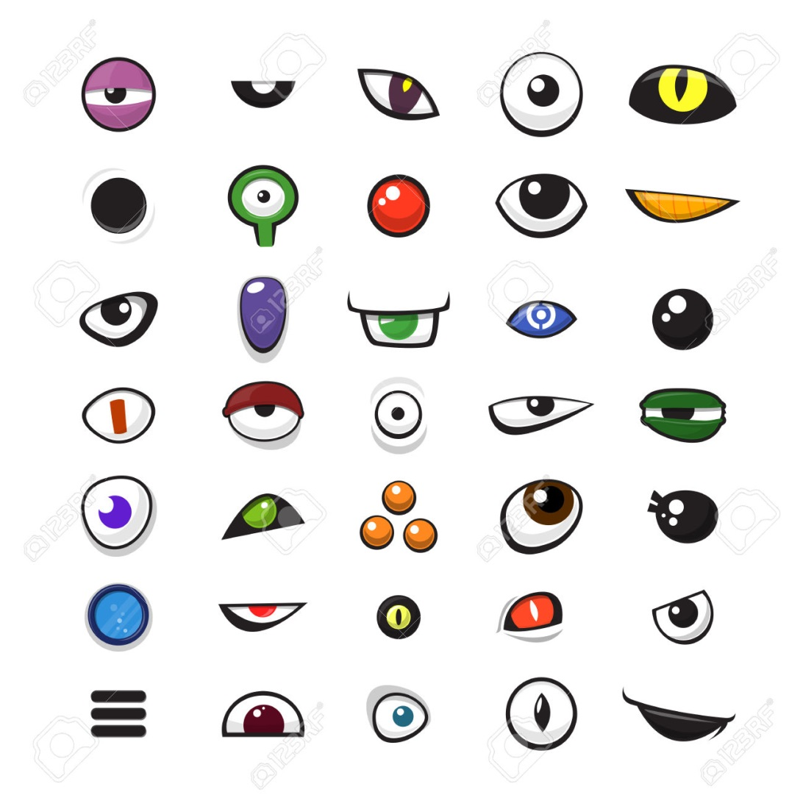](http://www.google.ca/url?sa=i&rct=j&q=&esrc=s&source=images&cd=&cad=rja&uact=8&ved=0CAcQjRxqFQoTCP28gZbxg8kCFQM0Pgod0asL6Q&url=http%3A%2F%2Ffr.123rf.com%2Fphoto_36474460_ensemble-de-yeux-vecteur-de-bande-dessinee-de-monstres-sur-fond-blanc--illustration-vectorielle.html&bvm=bv.106923889,d.cWw&psig=AFQjCNEvohkaUPeXbNmQnDnw40xmmI2wGw&ust=1447177125535961)

Originalité