**[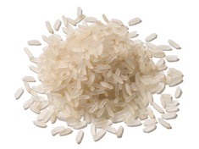](https://www.google.ca/url?sa=i&rct=j&q=&esrc=s&source=images&cd=&cad=rja&uact=8&ved=0CAcQjRxqFQoTCJS_0YGZ7cgCFUY3Pgod8PcENQ&url=http://blog.ac-rouen.fr/ecole-hugo-notre-dame-de-bondeville-cp/author/ecole-hugo-notre-dame-de-bondeville-cp/page/19/&bvm=bv.106379543,d.dmo&psig=AFQjCNFNzf4n69wpuk-sF2IKHtjgvEOTKA&ust=1446397566447274)[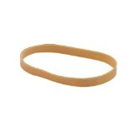](https://www.google.ca/url?sa=i&rct=j&q=&esrc=s&source=images&cd=&cad=rja&uact=8&ved=0CAcQjRxqFQoTCI--t4ea7cgCFYIWPgodDTwJ6g&url=http://www.amazon.fr/Elastique/b?ie=UTF8&node=205362031&bvm=bv.106379543,d.dmo&psig=AFQjCNH65BLF4FywQNaAZhfJAC5wrqUaKg&ust=1446397836132707)[](https://www.google.ca/url?sa=i&rct=j&q=&esrc=s&source=images&cd=&cad=rja&uact=8&ved=0CAcQjRxqFQoTCJS_0YGZ7cgCFUY3Pgod8PcENQ&url=http://blog.ac-rouen.fr/ecole-hugo-notre-dame-de-bondeville-cp/author/ecole-hugo-notre-dame-de-bondeville-cp/page/19/&bvm=bv.106379543,d.dmo&psig=AFQjCNFNzf4n69wpuk-sF2IKHtjgvEOTKA&ust=1446397566447274)Étapes pour créer notre instrument de musique**

**1**.

****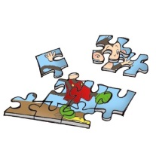**[](https://www.google.ca/url?sa=i&rct=j&q=&esrc=s&source=images&cd=&cad=rja&uact=8&ved=0CAcQjRxqFQoTCI--t4ea7cgCFYIWPgodDTwJ6g&url=http://www.amazon.fr/Elastique/b?ie=UTF8&node=205362031&bvm=bv.106379543,d.dmo&psig=AFQjCNH65BLF4FywQNaAZhfJAC5wrqUaKg&ust=1446397836132707)**

**4**.

**5**.

**6**.

**2**.

**3**.