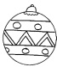**Les décorations de mon sapin**

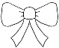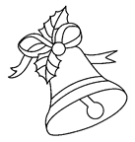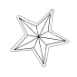Je veux décorer mon sapin avec 15 objets. J’ai des boules ,des étoiles , des cloches et des boucles .

Je dois respecter ces consignes pour plaire au Père-Noël :

* 3 boucles
* Plus de boules que de cloches
* Autant d’étoiles que de boules

Sur mon mur, j’ajoute une banderole avec des et des .

Je veux avoir 2 couleurs sur ma banderole. Elle doit respecter une régularité. Dessine la banderole et complète mon sapin.

|  |  |
| --- | --- |
| **Ce que je sais** | **Ce que je cherche** |

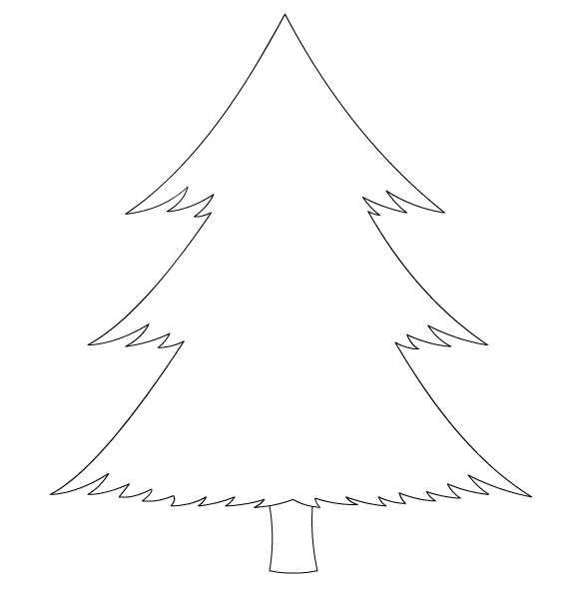

|  |  |  |  |  |  |
| --- | --- | --- | --- | --- | --- |
| http://www.teteamodeler.com/images/illustration/Image/pave_central/wpecolnoel23.jpg | http://www.teteamodeler.com/images/illustration/Image/pave_central/wpecolnoel23.jpg | http://www.teteamodeler.com/images/illustration/Image/pave_central/wpecolnoel23.jpg | http://www.teteamodeler.com/images/illustration/Image/pave_central/wpecolnoel23.jpg | http://www.teteamodeler.com/images/illustration/Image/pave_central/wpecolnoel23.jpg | http://www.teteamodeler.com/images/illustration/Image/pave_central/wpecolnoel23.jpg |
| http://www.teteamodeler.com/images/illustration/Image/pave_central/wpecolnoel23.jpg | http://www.teteamodeler.com/images/illustration/Image/pave_central/wpecolnoel23.jpg | https://encrypted-tbn2.gstatic.com/images?q=tbn:ANd9GcRSjGUdjbw2ZdrXgYfvGx-xzqanfaBVS62yL61Mcl-2UO4QuhuT | https://encrypted-tbn2.gstatic.com/images?q=tbn:ANd9GcRSjGUdjbw2ZdrXgYfvGx-xzqanfaBVS62yL61Mcl-2UO4QuhuT | https://encrypted-tbn2.gstatic.com/images?q=tbn:ANd9GcRSjGUdjbw2ZdrXgYfvGx-xzqanfaBVS62yL61Mcl-2UO4QuhuT | https://encrypted-tbn2.gstatic.com/images?q=tbn:ANd9GcRSjGUdjbw2ZdrXgYfvGx-xzqanfaBVS62yL61Mcl-2UO4QuhuT |
| https://encrypted-tbn2.gstatic.com/images?q=tbn:ANd9GcRSjGUdjbw2ZdrXgYfvGx-xzqanfaBVS62yL61Mcl-2UO4QuhuT | http://www.mescoloriages.com/coloriages/noel/cloches/thumbnails/2_gif.gif | http://www.mescoloriages.com/coloriages/noel/cloches/thumbnails/2_gif.gif | http://www.mescoloriages.com/coloriages/noel/cloches/thumbnails/2_gif.gif | http://www.mescoloriages.com/coloriages/noel/cloches/thumbnails/2_gif.gif | http://www.mescoloriages.com/coloriages/noel/cloches/thumbnails/2_gif.gif |
| http://www.mescoloriages.com/coloriages/noel/cloches/thumbnails/2_gif.gif | http://www.mescoloriages.com/coloriages/noel/cloches/thumbnails/2_gif.gif | http://www.mescoloriages.com/coloriages/noel/cloches/thumbnails/2_gif.gif | http://www.mescoloriages.com/coloriages/noel/cloches/thumbnails/2_gif.gif | http://azcoloriage.com/coloriages/x4c/kdB/x4ckdByT9.jpg | http://azcoloriage.com/coloriages/x4c/kdB/x4ckdByT9.jpg |
| http://azcoloriage.com/coloriages/x4c/kdB/x4ckdByT9.jpg | http://azcoloriage.com/coloriages/x4c/kdB/x4ckdByT9.jpg | http://azcoloriage.com/coloriages/x4c/kdB/x4ckdByT9.jpg | http://azcoloriage.com/coloriages/x4c/kdB/x4ckdByT9.jpg | http://azcoloriage.com/coloriages/x4c/kdB/x4ckdByT9.jpg | http://azcoloriage.com/coloriages/x4c/kdB/x4ckdByT9.jpg |

|  |  |  |  |  |  |
| --- | --- | --- | --- | --- | --- |
| http://www.teteamodeler.com/images/illustration/Image/pave_central/wpecolnoel23.jpg | http://www.teteamodeler.com/images/illustration/Image/pave_central/wpecolnoel23.jpg | http://www.teteamodeler.com/images/illustration/Image/pave_central/wpecolnoel23.jpg | http://www.teteamodeler.com/images/illustration/Image/pave_central/wpecolnoel23.jpg | http://www.teteamodeler.com/images/illustration/Image/pave_central/wpecolnoel23.jpg | http://www.teteamodeler.com/images/illustration/Image/pave_central/wpecolnoel23.jpg |
| http://www.teteamodeler.com/images/illustration/Image/pave_central/wpecolnoel23.jpg | http://www.teteamodeler.com/images/illustration/Image/pave_central/wpecolnoel23.jpg | https://encrypted-tbn2.gstatic.com/images?q=tbn:ANd9GcRSjGUdjbw2ZdrXgYfvGx-xzqanfaBVS62yL61Mcl-2UO4QuhuT | https://encrypted-tbn2.gstatic.com/images?q=tbn:ANd9GcRSjGUdjbw2ZdrXgYfvGx-xzqanfaBVS62yL61Mcl-2UO4QuhuT | https://encrypted-tbn2.gstatic.com/images?q=tbn:ANd9GcRSjGUdjbw2ZdrXgYfvGx-xzqanfaBVS62yL61Mcl-2UO4QuhuT | https://encrypted-tbn2.gstatic.com/images?q=tbn:ANd9GcRSjGUdjbw2ZdrXgYfvGx-xzqanfaBVS62yL61Mcl-2UO4QuhuT |
| https://encrypted-tbn2.gstatic.com/images?q=tbn:ANd9GcRSjGUdjbw2ZdrXgYfvGx-xzqanfaBVS62yL61Mcl-2UO4QuhuT | http://www.mescoloriages.com/coloriages/noel/cloches/thumbnails/2_gif.gif | http://www.mescoloriages.com/coloriages/noel/cloches/thumbnails/2_gif.gif | http://www.mescoloriages.com/coloriages/noel/cloches/thumbnails/2_gif.gif | http://www.mescoloriages.com/coloriages/noel/cloches/thumbnails/2_gif.gif | http://www.mescoloriages.com/coloriages/noel/cloches/thumbnails/2_gif.gif |
| http://www.mescoloriages.com/coloriages/noel/cloches/thumbnails/2_gif.gif | http://www.mescoloriages.com/coloriages/noel/cloches/thumbnails/2_gif.gif | http://www.mescoloriages.com/coloriages/noel/cloches/thumbnails/2_gif.gif | http://www.mescoloriages.com/coloriages/noel/cloches/thumbnails/2_gif.gif | http://azcoloriage.com/coloriages/x4c/kdB/x4ckdByT9.jpg | http://azcoloriage.com/coloriages/x4c/kdB/x4ckdByT9.jpg |
| http://azcoloriage.com/coloriages/x4c/kdB/x4ckdByT9.jpg | http://azcoloriage.com/coloriages/x4c/kdB/x4ckdByT9.jpg | http://azcoloriage.com/coloriages/x4c/kdB/x4ckdByT9.jpg | http://azcoloriage.com/coloriages/x4c/kdB/x4ckdByT9.jpg | http://azcoloriage.com/coloriages/x4c/kdB/x4ckdByT9.jpg | http://azcoloriage.com/coloriages/x4c/kdB/x4ckdByT9.jpg |