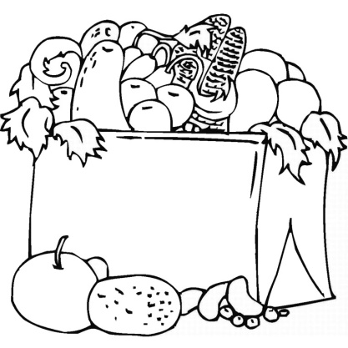Équipes de travail pour la recherche sur l’alpaga

Équipe 1 : ________________________

1) __________________________________________  
2) __________________________________________  
3) __________________________________________  
4) __________________________________________  
5) __________________________________________  
6) __________________________________________

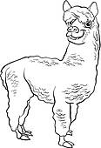  
Équipe 2 : _________________________

1) __________________________________________  
2) __________________________________________  
3) __________________________________________  
4) __________________________________________  
5) __________________________________________  
6) __________________________________________

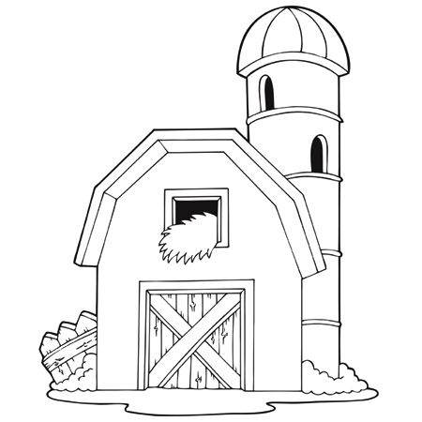  
Équipe 3 : ______________________________

1) __________________________________________  
2) __________________________________________  
3) __________________________________________  
4) __________________________________________  
5) __________________________________________  
6) __________________________________________

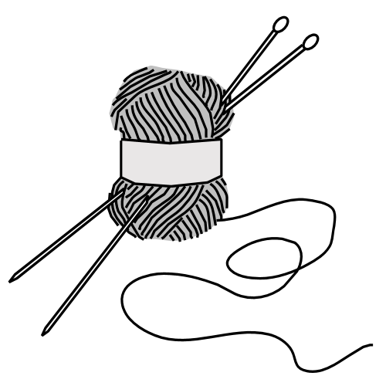  
Équipe 4 : _______________________________

1) __________________________________________  
2) __________________________________________  
3) __________________________________________  
4) __________________________________________  
5) __________________________________________  
6) __________________________________________