

________________________________________________

________________________________________________

Ingrédients :

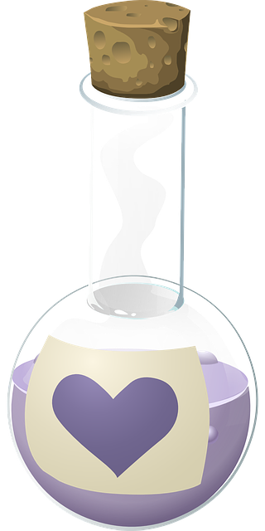 ________________________________________________________________

________________________________________________________________

________________________________________________________________

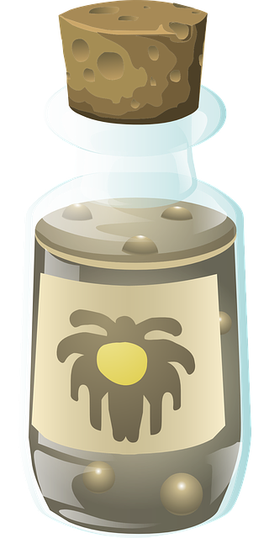 ________________________________________________________________

 ________________________________________________________________

________________________________________________________________

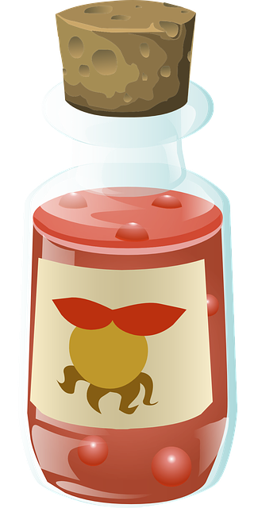 ________________________________________________________________

________________________________________________________________

 ________________________________________________________________

________________________________________________________________

Recette :

Dans un grand bol, mélangez :

_________________________________________________

400 ml de _________________________________________________

_________________________________________________________

10 _________________________________________________________

_________________________________________________________

_________________________________________________________

_______________________________________________

2 pincées de _______________________________________________

______________________________________________

10 gouttes de ______________________________________________

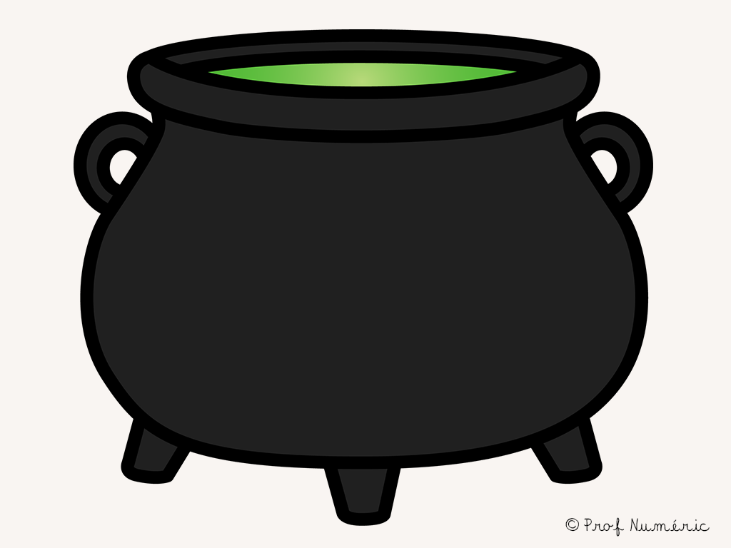

____________________________

Versez ensuite le mélange dans ____________________________.

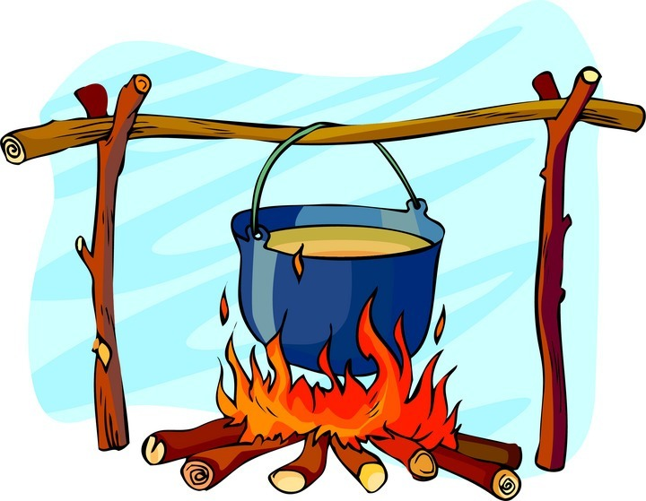

______________

Faites cuire ______________minutes à 200°.

Bonne appétit !

______________________________

Créée par : ______________________________