**[](http://www.google.ca/url?sa=i&rct=j&q=&esrc=s&frm=1&source=images&cd=&cad=rja&uact=8&docid=oqFE4ES7m5M4aM&tbnid=sDA9RvV1M6ZKpM:&ved=0CAcQjRw&url=http%3A%2F%2Flesideesdelaurea.com%2F2014%2F03%2Ffaire-un-coussin-nuage-tuto%2F&ei=mUcsVKDBJZWlyASE9YLADQ&psig=AFQjCNHz-klPgblV6jV6gJjP9aZi25YjKQ&ust=1412274396417673)[](http://www.google.ca/url?sa=i&rct=j&q=&esrc=s&frm=1&source=images&cd=&cad=rja&uact=8&docid=MpnGr6ywQWAY5M&tbnid=xAAca1VF9SN5DM:&ved=0CAcQjRw&url=http%3A%2F%2Fwww.colorier-dessin.com%2Fsoleil.php&ei=CkcsVNCZOIicygTg2oCYBA&bvm=bv.76477589,d.cWc&psig=AFQjCNHL8-TpttA1Z7D9gBahsJzC7IKHIQ&ust=1412269302774244)Rallye fiche 1**

[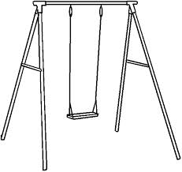](http://www.google.ca/url?sa=i&source=images&cd=&cad=rja&uact=8&docid=FzKLFnhl0Ts0eM&tbnid=5qnEVESgjDLrbM&ved=0CAgQjRw&url=http%3A%2F%2Fwww.phonemus.fr%2Fgallery.htm&ei=S0ssVNn2OdLGsQSdoYH4DQ&psig=AFQjCNH5JhaZBGuwgEU2Q1yH_yGPSQqGTA&ust=1412275404138390)

[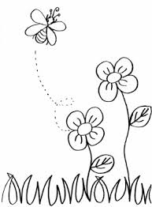](http://www.google.ca/url?sa=i&rct=j&q=&esrc=s&frm=1&source=images&cd=&cad=rja&uact=8&docid=iS0cbzYHQVjjHM&tbnid=fCf3Por1n4mfZM:&ved=0CAcQjRw&url=http%3A%2F%2Fzigomettecom.centerblog.net%2F6520609-Herbe-et-fleurs&ei=dUgsVNzmBcezyASgn4DYAQ&bvm=bv.76477589,d.aWw&psig=AFQjCNF1QZ89HTC4CqSAHoQXkfovvp3SYA&ust=1412274670360298)

[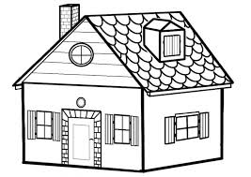](http://www.google.ca/url?sa=i&rct=j&q=&esrc=s&frm=1&source=images&cd=&cad=rja&uact=8&docid=dycaPhNNfAADVM&tbnid=gVykmhFyQTB0hM:&ved=0CAcQjRw&url=http%3A%2F%2Fkucink.com%2Fcoloriage%2Fcoloriage-a-imprimer-maison.aspx&ei=FjMsVLzpOoeyggTozoKwAQ&bvm=bv.76477589,d.cWc&psig=AFQjCNHKLWxTAdKrmLWaWlCfvYHusm9KCg&ust=1412269160384873)

[](http://www.google.ca/url?sa=i&rct=j&q=&esrc=s&frm=1&source=images&cd=&cad=rja&uact=8&docid=iS0cbzYHQVjjHM&tbnid=fCf3Por1n4mfZM:&ved=0CAcQjRw&url=http%3A%2F%2Fzigomettecom.centerblog.net%2F6520609-Herbe-et-fleurs&ei=dUgsVNzmBcezyASgn4DYAQ&bvm=bv.76477589,d.aWw&psig=AFQjCNF1QZ89HTC4CqSAHoQXkfovvp3SYA&ust=1412274670360298)

[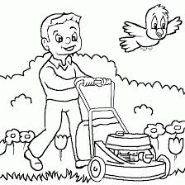](http://www.google.ca/url?sa=i&rct=j&q=&esrc=s&frm=1&source=images&cd=&cad=rja&uact=8&docid=6y_gZWG-s-7YGM&tbnid=RaDhg5VM2CroRM:&ved=0CAcQjRw&url=http%3A%2F%2Fwww.coloriage-jeux.com%2Fimprimer%2Fcoloriage%2Cde%2Cjardin%2Cau%2Cprintemps.html&ei=OkgsVPOPKIWqyQSI34CABg&bvm=bv.76477589,d.aWw&psig=AFQjCNE6Nf64j50DN_ekq624Zrxh7u0vMw&ust=1412274592679555)

[](http://www.google.ca/url?sa=i&rct=j&q=&esrc=s&frm=1&source=images&cd=&cad=rja&uact=8&docid=iS0cbzYHQVjjHM&tbnid=fCf3Por1n4mfZM:&ved=0CAcQjRw&url=http%3A%2F%2Fzigomettecom.centerblog.net%2F6520609-Herbe-et-fleurs&ei=dUgsVNzmBcezyASgn4DYAQ&bvm=bv.76477589,d.aWw&psig=AFQjCNF1QZ89HTC4CqSAHoQXkfovvp3SYA&ust=1412274670360298)