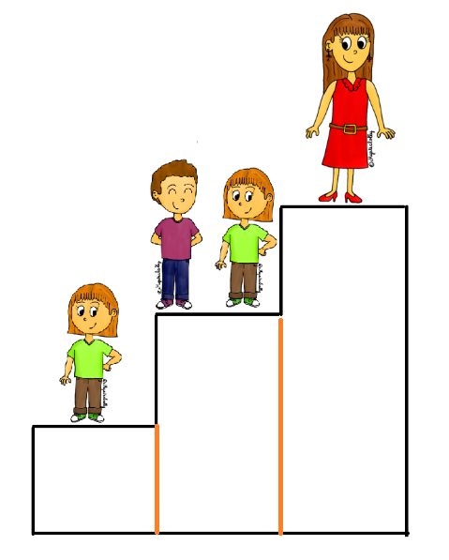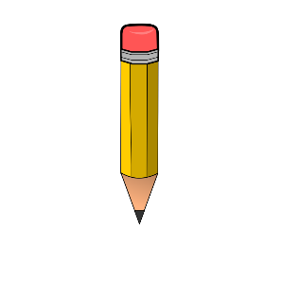

[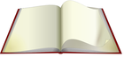](http://www.wpclipart.com/blanks/book_blank/book_turning_page.png.html)[](http://www.wpclipart.com/education/supplies/paper/paper_2/lined_paper_w_pen.png.html)[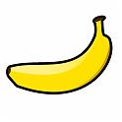](http://www.cslaval.qc.ca/apo/albumOOo/Nourriture-fruits/slides/banana.html)