**Les Trois Petits Cochons**

**Carnet de route**

**Nom :**

**Bonjour à toi,**

**Au courant des prochaines semaines, tu découvriras plusieurs livres de l’histoire des trois petits cochons. Tu auras à faire plusieurs activités en lien avec cette histoire, tu rencontreras plusieurs personnages et tu réaliseras plusieurs choses…**

**Es-tu prêt à vivre cette aventure avec nous?**

**Bonne lecture et bon travail!**

**Nouf-Nouf, Nif-Nif et Naf-Naf**

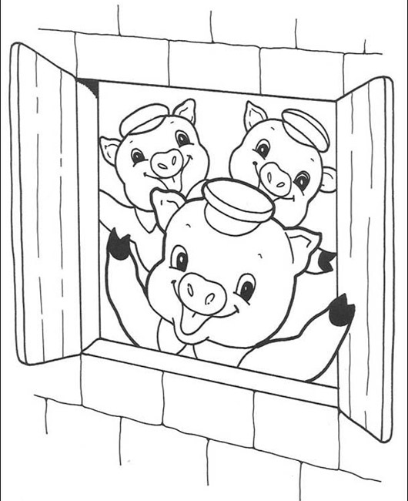

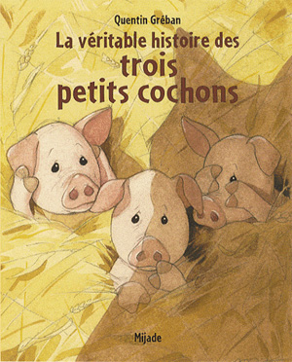

Personnages :

______________________________________________________________________________________________________________________________

____________________________________________________________________________________

____________________________________________________________________________________

____________________________________________________________________________________

____________________________________________________________________________________

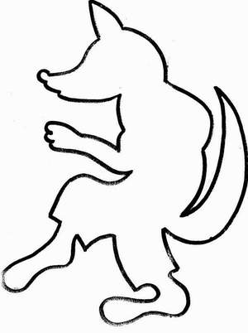

Début de l’histoire :

____________________________________________________________________________________________________________________

____________________________________________________________________________________________________________________

____________________________________________________________________________________________________________________

____________________________________________________________________________________________________________________

____________________________________________________________________________________________________________________

____________________________________________________________________________________________________________________

Début de l’his

Illustre le début :

Illustre le début de l’histoire :

Milieu de l’histoire :

____________________________________________________________________________________________________________________________

____________________________________________________________________________________________________________________________

____________________________________________________________________________________________________________________________

____________________________________________________________________________________________________________________________

____________________________________________________________________________________________________________________________

____________________________________________________________________________________________________________________________

Illustre le milieu :

Illustre le milieu de l’histoire :

Fin de l’histoire :

________________________________________________________________________________________________________________________________

________________________________________________________________________________________________________________________________

________________________________________________________________________________________________________________________________

________________________________________________________________________________________________________________________________

_______________________________________________________________________________________________________________________________

________________________________________________________________________________________________________________________________

Illustre la fin de l’histoire :



**Personnages :**

Ce qui est pareil :

__________________________________________________________________________________________________________________________

__________________________________________________________________________________________________________________________

Ce qui est différent :

__________________________________________________________________________________________________________________________

__________________________________________________________________________________________________________________________

**Début de l’histoire :**

Ce qui est pareil :

__________________________________________________________________________________________________________________________

__________________________________________________________________________________________________________________________

Ce qui est différent :

__________________________________________________________________________________________________________________________

__________________________________________________________________________________________________________________________

**Milieu de l’histoire** :

Ce qui est pareil :

________________________________________________________________________________________________________________________

________________________________________________________________________________________________________________________

Ce qui est différent :

________________________________________________________________________________________________________________________

________________________________________________________________________________________________________________________

**Fin de l’histoire :**

Ce qui est pareil :

________________________________________________________________________________________________________________________

______________________________________________________________________________________________________________

Ce qui est différent :

______________________________________________________________________________________________________________

________________________________________________________________________________________________________________________

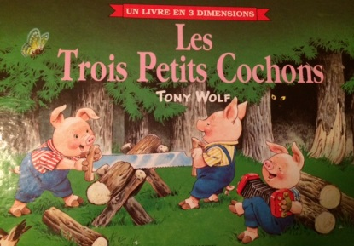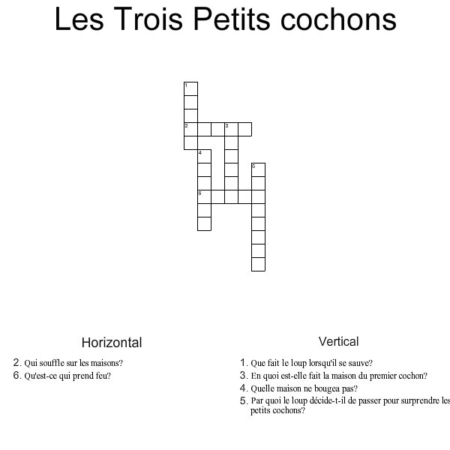

Queue Hurle Paille Brique Loup Cheminée

1. Est-ce que les trois petits cochons rencontrent des hommes qui leur vendent des matériaux?

____________________________________________________________________________________________________________________________________________

2. Que fait le premier cochon quand le loup détruit sa maison?

____________________________________________________________________________________________________________________________________________

____________________________________________________________________________________________________________________________________________

3. Est-ce que les cochons mangent le loup pour souper? Si non, qu’est-ce qui arrive?

____________________________________________________________________________________________________________________________________________

____________________________________________________________________________________________________________________________________________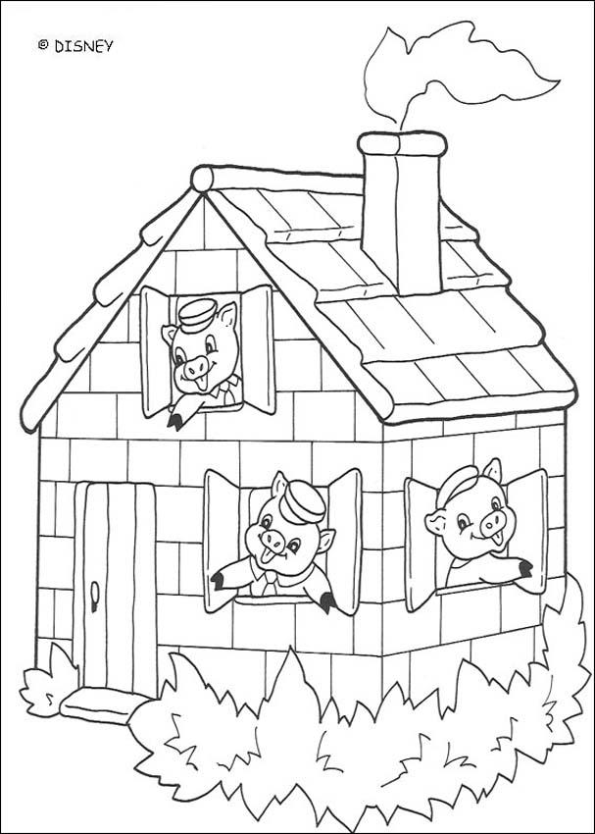

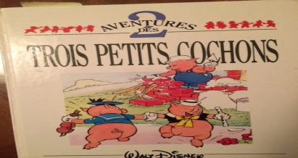

Replace les séquences de l’histoire en ordre.

Numérote-les de 1 à 6 dans les encadrés.

Naf-Naf construit sa maison en brique. 

Les trois frères chantent :

«Qui craint le Grand Méchant Loup? »



Le loup tombe dans le feu et se sauve. 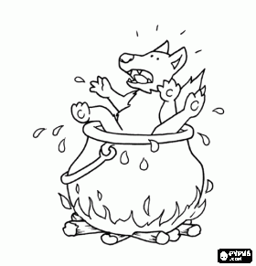

Nif-Nif construit sa maison en paille. 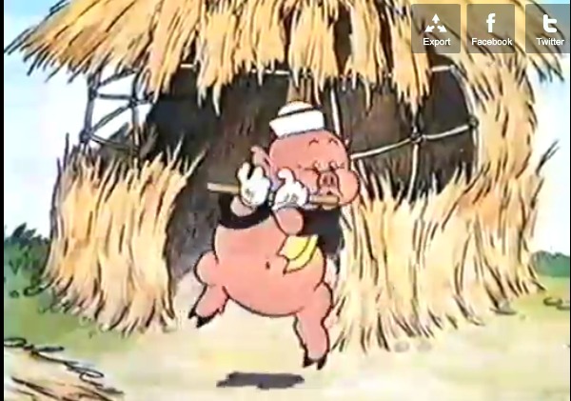

Le loup se déguise en mouton et souffle sur la maison de bois.

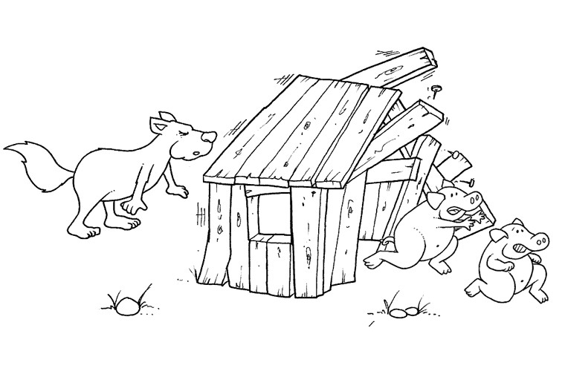

Le loup se déguise en marchand de brosses 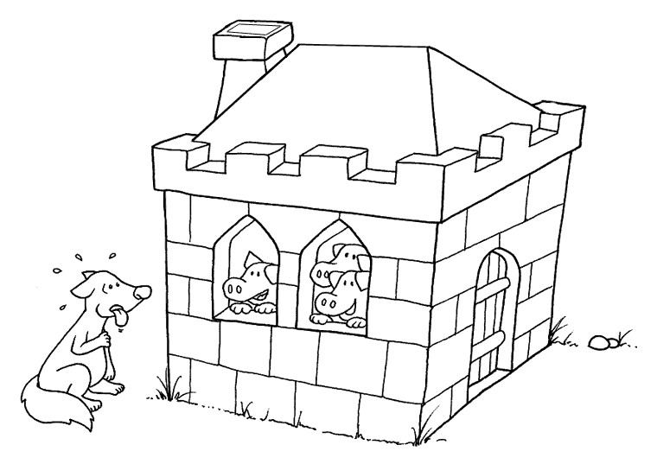

et tente de détruire la maison de brique.

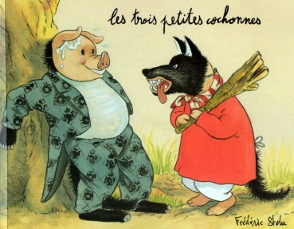

As-tu préféré la véritable histoire ou celle des trois petites cochonnes ? Pourquoi?

____________________________________________________________________________________________________________________________________________

____________________________________________________________________________________________________________________________________________

____________________________________________________________________________________________________________________________________________

____________________________________________________________________________________________________________________________________________

Nomme-moi deux choses de pareil dans les deux livres.

____________________________________________________________________________________________________________________________________________

____________________________________________________________________________________________________________________________________________

____________________________________________________________________________________________________________________________________________

Nomme-moi deux choses de différent dans les deux livres.

____________________________________________________________________________________________________________________________________________

____________________________________________________________________________________________________________________________________________

____________________________________________________________________________________________________________________________________________

Enéquipe de cinq, je vais te donner un des livres lus. Chacun son tour, tu dois lancer le dé et tu dois répondre à la question du numéro indiqué. Par exemple, si je lance le dé et qu’il tombe sur le numéro 5, je réponds à la question numéro 5 :



Maintenant que tu as connu plusieurs livres des trois petits cochons, ton ami Chester t’invite à jouer un tour et à faire comme lui.

Tu devras écrire ta propre histoire des trois petits cochons.

Attention, tu dois respecter ce qui est pareil dans tous les livres :

1. Trois petits cochons
2. Trois maisons
3. Un méchant loup qui vient détruire les maisons.

Alors, c’est à ton tour de jouer !!!

**Plan :**

Mes personnages :

______________________________________________________________________________________________________________________________________________

Début de l’histoire :

______________________________________________________________________________________________________________________________________________

______________________________________________________________________________________________________________________________________________

Milieu de l’histoire :

______________________________________________________________________________________________________________________________________________

______________________________________________________________________________________________________________________________________________

Fin de l’histoire :

__________________________________________________________________________________________________________________________________

__________________________________________________________________________________________________________________________________

_

Écriture :

________________________________________________________________________________________________________________________________

________________________________________________________________________________________________________________________________

________________________________________________________________________________________________________________________________

________________________________________________________________________________________________________________________________

________________________________________________________________________________________________________________________________

________________________________________________________________________________________________________________________________

________________________________________________________________________________________________________________________________

________________________________________________________________________________________________________________________________

________________________________________________________________________________________________________________________________

________________________________________________________________________________________________________________________________

________________________________________________________________________________________________________________________________

________________________________________________________________________________________________________________________________

________________________________________________________________________________________________________________________________

________________________________________________________________________________________________________________________________

____________________________________________________________________________________________________________________________

____________________________________________________________________________________________________________________________

________________________________________________________________________________________________________________________________

________________________________________________________________________________________________________________________________

________________________________________________________________________________________________________________________________

________________________________________________________________________________________________________________________________

________________________________________________________________________________________________________________________________

________________________________________________________________________________________________________________________________

________________________________________________________________________________________________________________________________

________________________________________________________________________________________________________________________________

________________________________________________________________________________________________________________________________

________________________________________________________________________________________________________________________________

________________________________________________________________________________________________________________________________

________________________________________________________________________________________________________________________________

________________________________________________________________________________________________________________________________

________________________________________________________________________________________________________________________________

____________________________________________________________________________________________________________________________