**Épeler**

**Épeler**

r-h-i-n-o-c-é-r-o-s

[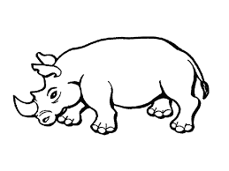](https://www.google.ca/imgres?imgurl&imgrefurl=http%3A%2F%2Fwww.greluche.info%2Fcoloriage-Rhinoceros-0.html&h=0&w=0&tbnid=UY7c4QCUi4UHfM&zoom=1&tbnh=194&tbnw=259&docid=0MNMP6pEtDmDgM&tbm=isch&ei=3o02VIn2BIGGyATbxIL4Bg&ved=0CAQQsCUoAA)

**Épeler**

**Épeler**

**Épeler**

**Épeler**